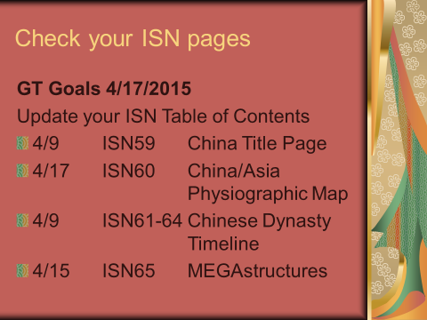
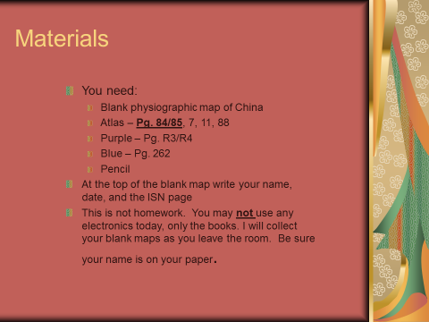
ISN P. 60 Asia/China Physiographic Map Instructions GT Goals 4/17 and 4/20/15
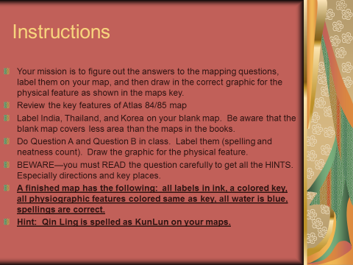
Mapping Questions
- What is the vast desert in northwestern China that helped isolate the country from West Asia?
- What is the body of water that is bounded by Japan, China, and Taiwan?
- What body of water is surrounded by the Asian mainland and Taiwan, the Philippines, and Borneo?
- What is the tallest peak in the Himalayas Mountains?
- What is the mountain range in western China that separates China from Tadzhikistan, Kirigizia, and Zazakhstan?
- What is the lowland region west of the Gobi Desert that, at 505 feet below sea level is China’s lowest point?
- What is the river that rises on the Tibetan Plateau and flows southeast to the South China Sea?
- What is the plain upon which China’s capital, Beijing, is located?
- What is the river that begins in the plateau of Tibet and runs across the farmlands of northeastern China?
- What is the plateau in the southwestern part of China that comprises approximately one fourth of the whole country?
- What is the mountain range south of the plateau of Tibet that extends 1,500 miles through six countries?
- What body of water is located between Korea and China?
- What is the river that flows from the plateau of Tibet across central and southern China to the East China Sea?
- What is the desert that extends 1,000 miles through southeast Mongolia and north China?
- What is the plateau in southern China where much of China’s rice is grown?
- What is the basin in central China that is south of the KunLun Mountains?

